**Physics 30 Diploma Exam Review**

Numerical Response

1. A 1 575 kg car, initially travelling at 10.0 m/s, collides with a stationary 2 250 kg car. The bumpers of the two cars become locked together. The speed of the combined cars immediately after impact is __________m/s.

(Record your **three-digit answer** in the numerical-response section on the answer sheet.)

1. In an inelastic collision, the energy that appears to be missing is converted into

A. sound and momentum

B. force and momentum

C. sound and heat

D. heat and force

1. A particular car has a mass of 1.60 × 103 kg. In a test drive, the car accelerated from 3.00 m/s to 15.0 m/s over a distance of 115 m. The magnitude of the impulse on the car during the test drive is

A. 4.80 × 103 kg·m/s

B. 1.92 × 104 kg·m/s

C. 2.40 × 104 kg·m/s

D. 2.88 × 104 kg·m/s

***Use your recorded answer from Multiple Choice 2 to answer Numerical Response 2.\****

**Numerical Response**

Numerical Response

1. The average net force on the car during the test drive, expressed in scientific notation, is ***a.bc*** × 10***d*** N. The values of ***a***, ***b***, ***c***, and ***d*** are ____, ____, ____, and ____.

(Record all **four digits** of your answer in the numerical-response section on the answer sheet.)

**\*You can receive marks for this question even if the previous question was answered incorrectly.**

*Use the following information to answer the next question.*

I. Energy

II. Displacement

III. Mass

IV. Acceleration

V. Force

1. Which of the above terms represent scalar quantities?

A. I and III only

B. III and V only

C. I, II, and III only

D. II, IV, and V only

Numerical Response

1. A 2.00 g bullet is fired from a rifle with an initial velocity of 841 m/s. If the rifle has a mass of 3.80 kg, the recoil speed of the rifle, expressed in scientific notation, is **a.bc** × 10**-d** m/s. The values of **a**, **b**, **c**, and **d** are _____, _____, _____, and _____ .

(Record all **four digits** in the numerical-response section on the answer sheet.)

1. The physical quantity that can have the same unit as impulse is

A. force

B. work

C. power

D. momentum

*Use the following information to answer the next question.*

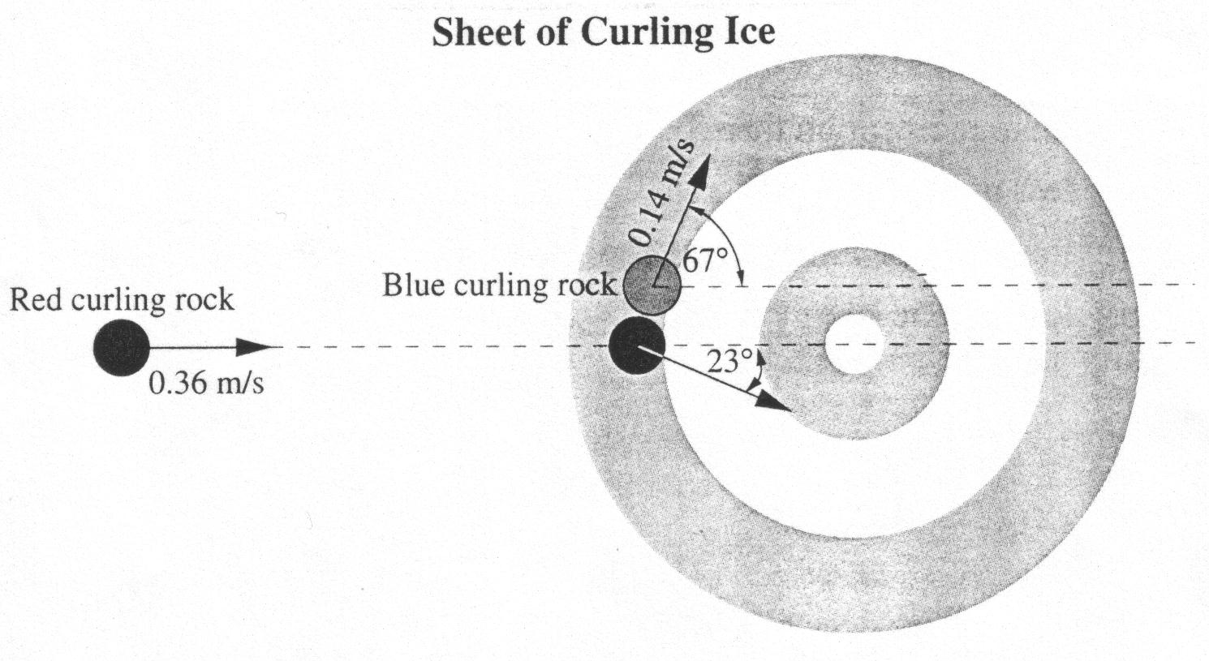

A red curling rock traveling straight down a sheet of ice at 0.36 m/s contacts a stationary blue curling rock. After contact, the blue rock moves at 0.14 m/s at an angle of 67o and the red rock moves at an angle of 23o, as illustrated. The mass of a curling rock is 18.8 kg.

1. The speed of the red rock, after contact, is

A. 0.15 m/s

B. 0.22 m/s

C. 0.33 m/s

D. 0.39 m/s

______________________________

*Use the following information to answer the next question.*

**A Street Light Shadow**

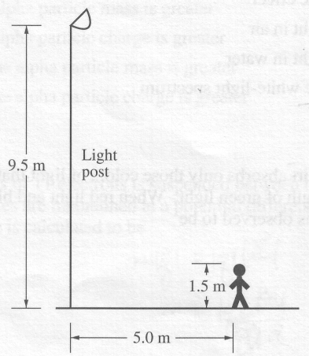

A girl who is 1.5 m tall stands on a level sidewalk 5.0 m away from a street light that is 9.5 m high. (This diagram is not drawn to scale.)

1. What is the length of the girl's shadow on the sidewalk?

A. 1.1 m

B. 0.94 m

C. 0.79 m

D. 0.43 m

________________________________

*Use the following information to answer the next question.*

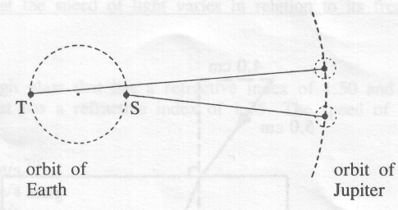

A group of amateur astronomers monitors the eclipse of one of Jupiter's moons over an extended period of time. From position S, the observed and calculated times are the same. From position T, the observed time is 19 min later than the calculated time.

1. Given that the diameter of the Earth's orbit is 3.0 × 1011 m, the speed of light as measured by the amateur astronomers is

A. 1.6 × 108 m/s

B. 2.6 × 108 m/s

C. 3.0 × 108 m/s

D. 1.6 × 1010 m/s

_______________________________

1. In comparing the wavelength, frequency, and speed of light in air to the same quantities in glass, one would find that

A. frequency, wavelength, and speed all differ

B. frequency is the same, but wavelength and speed differ

C. speed is the same, but wavelength and frequency differ

D. wavelength is the same, but frequency and speed differ

*Use the following information to answer the next question.*

**Michelson's Apparatus**

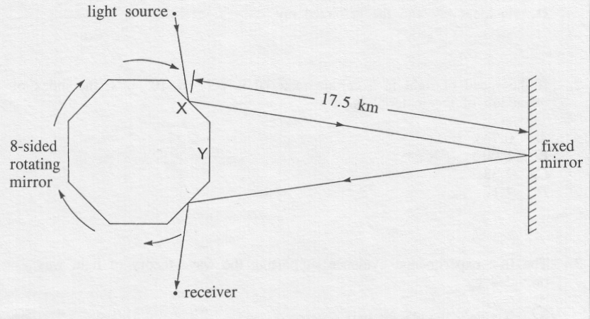

1. At what rate must the mirror rotate so that light striking face X will return to strike face Y and be detected at the receiver?

A. 1.07 × 103 rev/s

B. 2.14 × 103 rev/s

C. 8.57 × 103 rev/s

D. 1.07 × 106 rev/s

________________________________

*Use the following information to answer the next question.*

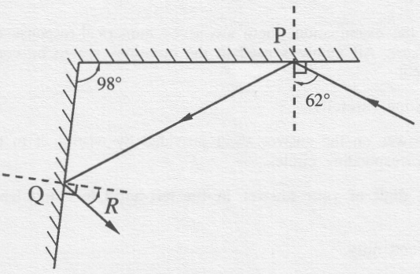

A light wave is reflected at P and again at Q. The diagram is not drawn to scale.

Numerical Response

1. The calculated value of angle R is _____ degrees.

(Record your **two‑digit answer** in the numerical‑response section on the answer sheet.)

_______________________________

*Use the following information to answer the next question.*

**Reflection and Refraction**

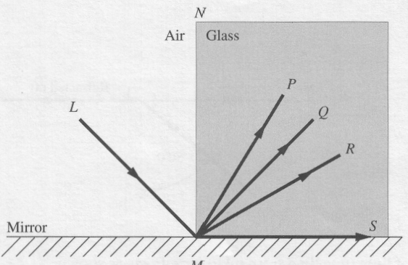

A block of glass rests on a mirror. A ray of light travelling in air is incident on the reflecting surface at point M, where the glass, the air, and the mirror surface meet. The angles NML and NMQ are equal in magnitude.

1. The reflected ray is represented by the line

A. MP

B. MQ

C. MR

D. MS

________________________________

1. The speed of light in a transparent material is three-fifths the speed of light in air. The index of refraction of the material is

A. 0.60

B. 1.7

C. 1.8

D. 2.5

*Use the following information to answer the next question.*

**Critical Angle**

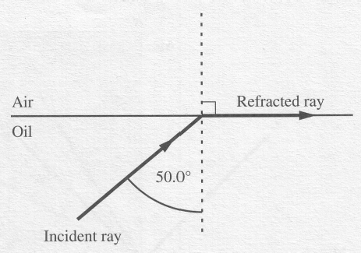

A ray of light travelling from oil to air refracts as shown.

1. If the wavelength of the light is 6.02 × 10-7 m in air, its wavelength in oil was

A. 7.86 × 10-7 m

B. 6.02 × 10-7 m

C. 4.61 × 10-7 m

D. 3.87 × 10-7 m

________________________________

1. The technology of fibre optics is possible due to

A. the wave nature of light.

B. the effect of total internal reflection.

C. the effect of refraction in glass.

D. the slow speed of light in glass.

1. A polarizing filter is set so that the light passing through it has MAXIMUM brightness. How far must the filter be rotated so that the light passing through it will be of MINIMUM brightness?

A. 360°

B. 180°

C. 135°

D. 90°

*Use the following information to answer the next question.*

Polarizing Filters

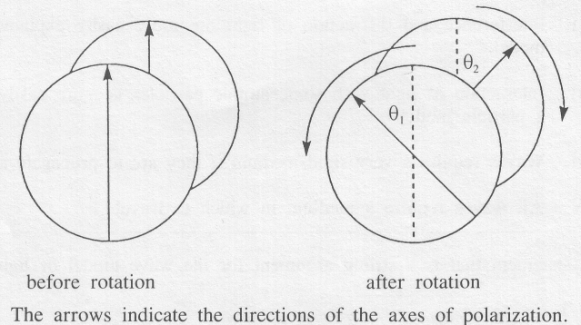

1. Two polarizing filters are rotated in opposite directions. If the axes of the filters are initially aligned, to what pair of angles could the filters be rotated so that there will be minimum transmission of light through the filters?

A. 1 = 22.5° and 2 = 22.5°

B. 1 = 30° and 2 = 60°

C. 1 = 40° and 2 = 60°

D. 1 = 90° and 2 = 90°

______________________________

1. The polarization of light can be best explained in terms of

A. particles with different amounts of energy

B. particles of different sizes

C. longitudinal waves

D. transverse waves

1. Light passes through a double slit and produces images on a screen that is 20.0 m away. If the second-order bright image is formed at a distance of 0.720 m from the central maximum, how far from the central maximum will the third-order bright image be formed?

A. 2.16 m

B. 1.08 m

C. 0.480 m

D. 0.240 m

1. If light with a frequency of 5.0 × 1014 Hz passes through a diffraction grating with 2000 lines/cm, the angle from the central maximum to the second-order bright fringe is

A. 3.5°

B. 7.0°

C. 14°

D. 21o

1. A diffraction grating that is 0.502 cm wide contains 4.50 × 103 lines. A beam of monochromatic light strikes the grating and produces a first-order image at an angle of 22.0°. The wavelength of the light is

A. 4.18 × 10-7 m

B. 8.36 × 10-7 m

C. 4.18 × 10-5 m

D. 8.36 × 10-5 m

1. If one wishes to use a lens to start a fire, one would use a

A. compound lens.

B. concave lens.

C. convex lens.

D. diverging lens.

1. A 6.0 cm object is located 20 cm in front of a convex mirror with a radius of curvature equal to 120 cm. What is the size of the image produced by the mirror?

A. + 3.6 cm

B. + 4.5 cm

C. + 9.0 cm

D. +18.0 cm

1. Which factor does not determine the focal length of a lens?

A. lens material

B. index of refraction

C. shape

D. object distance

1. A 12 cm object located in front of a curved mirror generates an erect image 24 cm tall located 60 cm from the mirror. What is the radius of curvature for the mirror?

A. 30 cm

B. 45 cm

C. 60 cm

D. 120 cm

1. An object located in front of a diverging lens with a focal length of 60 cm produces an erect image that is 1/5th the size of the object. What is the image distance?

A. –24 cm

B. –48 cm

C. –120 cm

D. –240 cm

1. The field resulting from a positive point charge and a negative point charge is best represented by

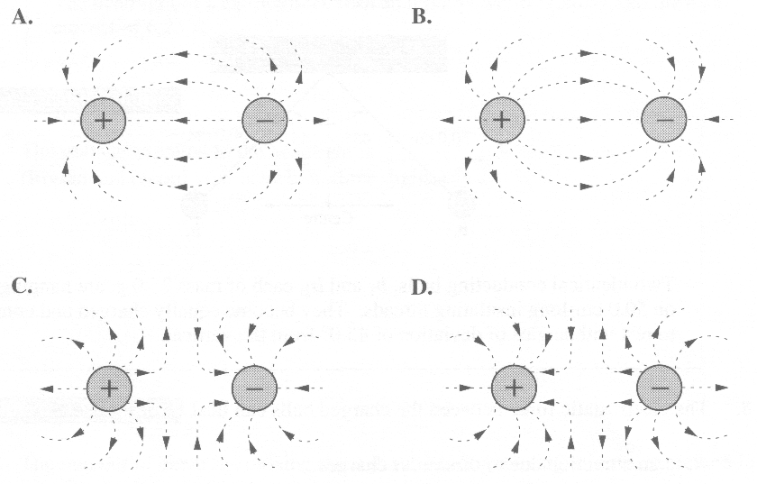

Numerical Response

1. Two charged objects experience a force of 18.0 N when they are placed 5.00 × 10-2 m apart. If the charge on one object is 1.30 × 10-5 C, then the charge on the other object is ***a.bc*** × 10-***d*** C. The values of ***a***, ***b***, ***c***, and ***d*** are _____ , _____ , _____ , and _____.

(Record all **four digits** of your answer in the numerical-response section on the answer sheet.)

1. The magnitude of an electric field at a distance *x* from a point charge *Q* is 8.3  10–4 N/C. If the distance is increased to 3*x* and the charge is reduced to ¼ *Q*, then the magnitude of the electric field will be

A. 1.9  10-3 N/C

B. 3.7  10-4 N/C

C. 6.9  10-5 N/C

D. 2.3  10-5 N/C

*Use the following information to answer the next question.*

**Resultant Electric Field**

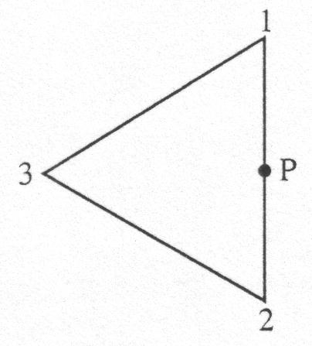

Three equal positive charges are located at the vertices of an equilateral triangle.

1. The direction of the electric field at point P is

A. up the page

B. down the page

C. to the left of the page

D. to the right of the page

______________________________

1. The electric field strength 2.0 × 10-10 m from an alpha particle is

A. 7.2 N/C

B. 14 N/C

C. 3.4 × 1010 N/C

D. 7.2 × 1010 N/C

1. Rubbing two objects such as plastic and wool together creates a static charge because

A. atoms are transferred from one object to another

B. electrons are transferred from atoms in one object to atoms in the other object

C. the electrons on one object are attracted to the nuclei in the other object

D. electrons become more widely distributed in each object

1. In charging by induction

A. a charged object can be used to change the charge of another charged object

B. a charged object can be used to charge a neutral object without touching it

C. a neutral object can be used to separate like charges

D. no charges are separated

1. The number of electrons represented by a charge of 2.5 C is

A. 2.5 × 1018

B. 6.4 × 1018

C. 1.6 × 1019

D. 4.0 × 1019

1. If an electron and a proton each accelerate from rest through a potential difference of 1000 Volts, they will have the same final

A. speed

B. momentum

C. kinetic energy

D. charge‑to‑mass ratio

1. In a Millikan oil drop experiment, the plates are 3.0 cm apart and an oil drop of mass 2.6 × 10‑9 g, is suspended between the plates. The potential difference between the plates is 260 V. The charge on the oil drop is

A. 2.9 × 10‑15 C

B. 2.9 × 10‑13 C

C. 2.9 × 10‑12 C

D. 2.9 × 10‑10 C

*Use the following information to answer the next question.*

**Magnetic Field of a Bar Magnet**

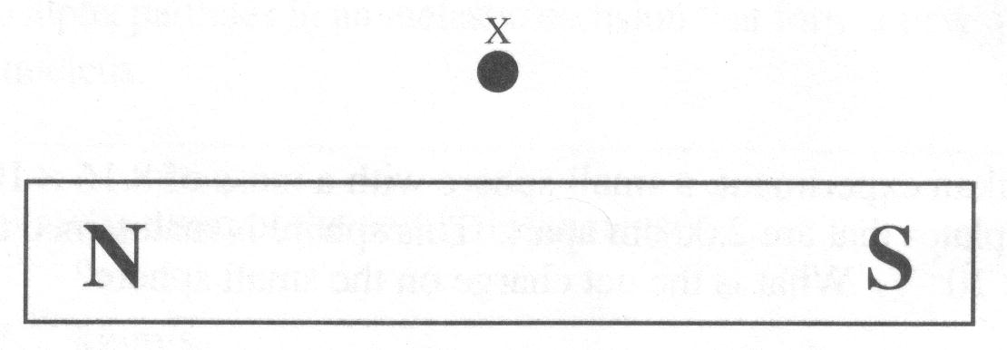

1. The direction of the magnetic field at point X is toward the

A. bottom of the page

B. right of the page

C. left of the page

D. top of the page

______________________________

*Use the following information to answer the next question.*

**Alpha Particles in Magnetic Fields**

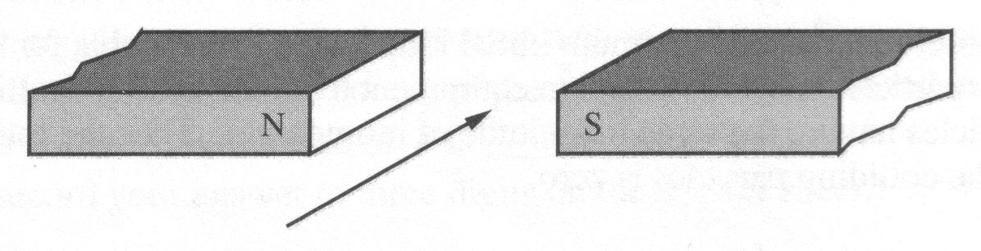

A horizontal beam of alpha particles is projected perpendicularly between a pair of magnetic poles.

1. The ions will be deflected

A. upward

B. downward

C. toward the north pole

D. toward the south pole

______________________________

*Use the following information to answer the next two questions.*

**XY** represents a section of a current‑carrying wire. **Conventional current** is flowing in the direction of the arrow. The magnetic field at any point around the wire is found using the formula



where o is a constant and R is the distance from the wire.

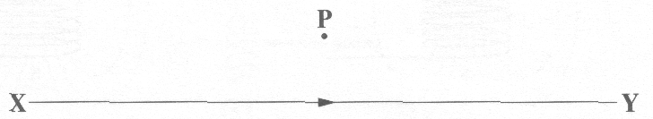

1. The direction of the magnetic field produced by the current in **XY** at point P is

A. out of the page

B. to the right

C. into the page

D. to the left

1. If the current in conductor **XY** is doubled and all other variables remain constant, then the magnetic field strength at point P will

A. decrease to one‑half of its present value

B. remain at its present value

C. increase to double its present value

D. increase to four times its present value

______________________________

1. An alpha particle and an electron traveling at the same speed enter perpendicularly into a uniform magnetic field. Which of the following statements concerning the acceleration of the particles is correct?

A. The acceleration of the alpha particle is greater because it experiences the greater force.

B. The acceleration of the electron is greater because it experiences the greater force.

C. The acceleration of the alpha particle is greater because its mass is greater.

D. The acceleration of the electron is greater because its mass is smaller.

*Use the following information to answer the next three questions.*

A cyclotron is a particle accelerator used to investigate subatomic structure. Magnetic fields are used to control the path of charged particles within a cyclotron.

1. The radius of the path followed by charged particles moving perpendicularly through the magnetic field of a cyclotron could be reduced by

A. increasing the strength of the magnetic field

B. using particles with a smaller charge

C. increasing the speed of the particles

D. using particles with a greater mass

1. The period *T* for a particle of charge *q* in a magnetic field of strength *B* is

A. 

B. 

C. 

D. 

1. An alpha particle travels in a direction perpendicular to a magnetic field of strength 1.6 T. If the alpha particle experiences a force of magnitude 1.1 × 10‑13 N, then its measured speed will be

A. 2.1 × 10-7 m/s

B. 4.3 × 10-7 m/s

C. 2.1 × 105 m/s

D. 4.3 × 105 m/s

______________________________

*Use the following information to answer the next question*.

In the apparatus illustrated below, coil I is suspended by an insulating string such that the coil can swing freely. Coil II is connected to a DC supply.

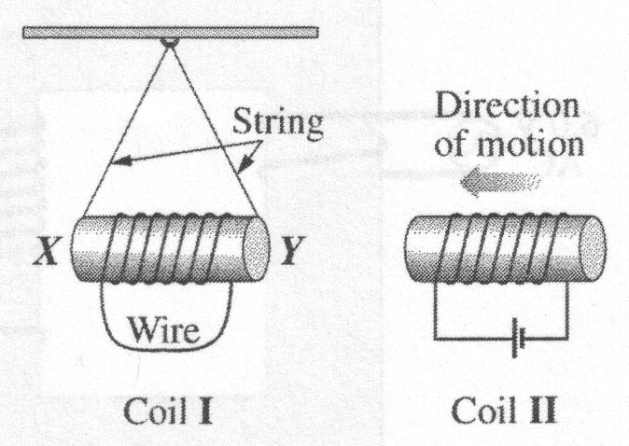

1. Which of the following statements describes what occurs when coil II is moved toward coil I?

A. The magnetic pole that is induced at Y is a north pole, and coil I swings away from coil II.

B. The magnetic pole that is induced at Y is a north pole, and coil I swings toward coil II.

C. The magnetic pole that is induced at Y is a south pole, and coil I swings away from coil II.

D. The magnetic pole that is induced at Y is a south pole, and coil I swings toward coil II.

______________________________

1. Scientists believe that chemical compounds found in far regions of space are the same as those found on Earth. Evidence for this has been provided in studies of

A. spectra

B. electricity

C. gravitation

D. magnetism

1. A current‑carrying wire is placed in an external magnetic field. The magnetic field exerts a force of 2.4 × 10-3 N on the wire when the current is 4.0 A. The length of the wire perpendicular to the magnetic field is 2.0 cm. The strength of the magnetic field is

A. 1.9 × 10-6 T

B. 1.9 × 10-4 T

C. 3.0 × 10-4 T

D. 3.0 × 10-2 T

1. An electromagnetic wave is created by

A. a constant electromagnet

B. a changing field of any kind

C. a magnet in an electric field

D. an accelerating electric charge

*Use the following information to answer the next question.*

Electrons can produce gravitational, electric, and magnetic fields as a result of the following properties.

**1** Charge

**2** Mass

**3** Speed

**Numerical Response**

Numerical Response

1. Match electron properties as listed above with the field that they produce as given below. You may use a number more than once. There is more than one correct answer.

**Property:** __________ __________ __________ and _________

**Field: Gravitational Constant Magnetic**

**Field Electric Field Field**

(Record all **four digits** of your answer in the numerical-response section on the answer sheet.)

1. The correct order of colors from higher to lower frequencies is

A. green, yellow, orange

B. blue, orange, violet

C. yellow, blue, red

D. violet, red, blue

1. In a particular medium, light with a frequency of 5.0 × 1014 Hz travels 10.0 m in 4.0 × 10-8 s. Its wavelength is

A. 4.2 × 10-7 m

B. 5.0 × 10-7 m

C. 6.0 × 10-7 m

D. 2.0 × 10-6 m

1. In glass (n = 1.50), a certain infra-red source has a wavelength of 800 nm. Its frequency is

A. 8.44 × 1014 Hz

B. 5.63 × 1014 Hz

C. 3.75 × 1014 Hz

D. 2.50 × 1014 Hz

1. Rutherford's planetary model of the atom was an improvement over previous models because it was able to explain the

A. existence of atoms

B. line spectra of hydrogen

C. existence of energy levels within atoms

D. scattering of alpha particles incident on a thin gold foil

1. When white light emitted by a glowing solid passes through a cool gas, the spectrum produced is

A. an emission spectrum

B. a bright-line spectrum

C. a continuous spectrum

D. an absorption spectrum

1. A photocathode that has a threshold frequency of 5.6 × 1014 Hz is illuminated with light that has a frequency of 8.2 × 1014 Hz. The maximum kinetic energy of the ejected photoelectrons is

A. 1.7 × 10–19 J

B. 3.7 × 10–19 J

C. 5.4 × 10–19 J

D. 9.1 × 10–19 J

1. One immediate result of the discovery of cathode ray particles was that the theory of the atom was revised to a theory that hypothesized that

A. an atom is an indivisible sphere

B. electrons exist in probability clouds

C. an atom is mostly made up of empty space

D. an atom contains negatively charged particles

1. *The analysis of the observations from the Rutherford alpha particle scattering experiment lead to a model of the atom in which the__* ***i__*** *is on the order of 10–10 m in diameter, the __****ii__*** *is on the order of 10–15 m in diameter, and the majority of the __****iii__*** *of the atom is in the nucleus.*

The statements above are completed by the information in row

|  |  |  |  |
| --- | --- | --- | --- |
| **Row** | ***i*** | ***ii*** | ***iii*** |
| A. | atom | nucleus | charge |
| B. | nucleus | atom | charge |
| C. | atom | nucleus | mass |
| D. | nucleus | atom | mass |

*Use the following information to answer the next four questions*.

Researchers have found that lightning consists of both downward and return (upward) strikes. A barely visible downward strike causes a path of gas molecules to become ionized. Although every lightning event is a unique occurrence, the following describes one possible chain of events.

The bottom of a cloud is 1.2 × 103 m above Earth's surface. An electrical potential difference of 4.0 × 107 V exists between the bottom of the cloud and Earth. As a result of a downward strike, much of the negative charge on the bottom of the cloud is channelled off. A bright and very visible return strike carries electron currents of 3.0 × 105 A for 2.5 × 10-2 s from Earth to the top of the cloud. The top of the cloud, which is positively charged, is 1.6 × 104 m above Earth's surface. The return strike is driven by an electrical potential difference of 1.0 × 108 V between the top of the cloud and Earth.

In the thin air above the cloud, a second electric field exists between the ionosphere and the top of the cloud. Some of the electrons continue to accelerate upward, beyond the top of the cloud. Collisions between these electrons and air molecules can produce phenomena called "sprites" – red flashes of light with a wavelength of 6.8 × 10-7 m.

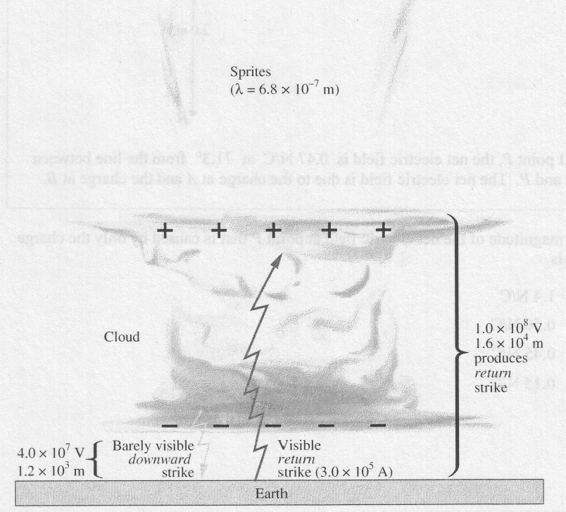

1. If a person is out in the open in a thunderstorm, he might feel the hair on his arms and neck stand on end because they are acquiring charge as a result of the charge on the clouds above. Prior to a lightning strike, the hair acquires this charge through the process of

A. friction

B. radiation

C. induction

D. conduction

1. The electric field that exists between the bottom of the cloud and Earth's surface just before the downward strike is

A. 3.3 × 104 N/C, downward

B. 6.3 × 103 N/C, downward

C. 3.3 × 104 N/C, upward

D. 6.3 × 103 N/C, upward

Numerical Response

1. The charge transferred during the visible return strike, expressed in scientific notation, is _____ × 10*w* C.

(Record your **two-digit** **answer** in the numerical-response section on the answer sheet.)

1. *In order for red sprites to be produced above the cloud, the minimum speed that the electrons must have is ___****i****___. The law of conservation of ___****i****___ is valid for this situation*.

The statements above are completed by the information in row

|  |  |  |
| --- | --- | --- |
| **Row** | ***i*** | ***ii*** |
| A. | 6.4 × 1011 m/s | energy |
| B. | 8.0 × 105 m/s | energy |
| C. | 6.4 × 1011 m/s | momentum |
| D. | 8.0 × 105 m/s | momentum |

______________________________

*Use the following information to answer the next three questions.*

In a Millikan-like oil-drop experiment, a charged oil drop is suspended in the region between two horizontal parallel plates that are 2.00 cm apart. The electric field between the plates is 1.76 × 104 N/C, toward the top plate. The mass of the oil drop is 8.61 × 10-16 kg.

1. The electrical potential difference between the parallel plates is

A. 3.52 × 102 V

B. 8.80 × 103 V

C. 3.52 × 104 V

D. 8.80 × 105 V

1. The type and magnitude of charge present on the oil drop is

A. –4.80 × 10-19 C

B. –1.60 × 10-19 C

C. +1.60 × 10-19 C

D. +4.80 × 10-19 C

*Use the following additional information to answer the next question*.

The oil drop is irradiated with high-energy X-rays. The charge on the drop changes and the drop accelerates upward.

1. If the magnitude of the new charge on the drop is 8e, then the drop's net upward acceleration is

A. 9.81 m/s2

B. 16.4 m/s2

C. 26.2 m/s2

D. 36.0 m/s2

_________________________________________

*Use the following information to answer the next question.*

**Photoelectric Effect**

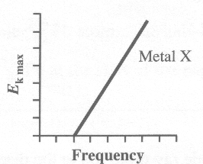

This graph shows the relationship between the maximum kinetic energy for emitted photoelectrons and the frequency of incident light for Metal X.

Note: The five graphs in this question are drawn to the same scale.

1. Metal Y has a different work function from Metal X. The graph that **could** represent the relationship between the maximum kinetic energy for emitted photoelectrons and the frequency of incident light for Metal Y is

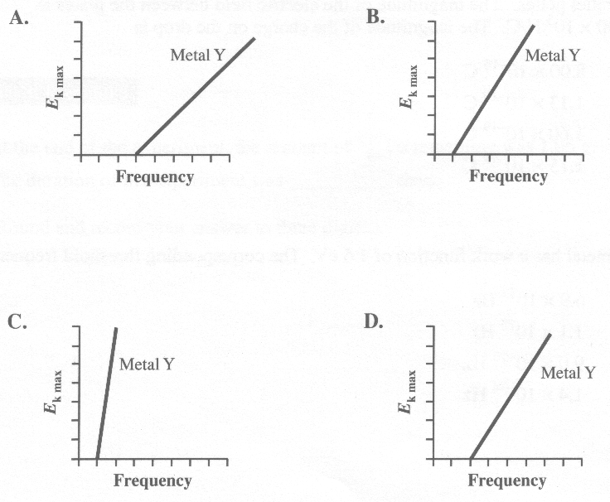

______________________________

1. The equation *hf* = *q*e*V*stop + *W* for the photoelectric effect is derived using the physics principle of conservation of

A. charge

B. energy

C. nucleons

D. momentum

1. One of the reasons that Rutherford's planetary model of the atom has been modified is that observations of the atom do not support the theory of electrons orbiting the nucleus in a manner similar to planets orbiting a star. However, according to Maxwell's theory of electromagnetic radiation, such an orbiting electron should emit electromagnetic radiation because

A. the electron is travelling at uniform speed

B. the electron is accelerating toward the nucleus

C. there is an electrostatic force of repulsion between the orbiting electrons

D. there is an alternating electromagnetic dipole as the electron switches sides of the nucleus

*Use the following information to answer the next question*.

Louis de Broglie determined that the wavelength of a particle with mass and speed is given by the equation 

1. If a proton and an electron have identical speeds, then the proton will have a

A. longer wavelength and a smaller momentum than those of the electron

B. shorter wavelength and a greater momentum than those of the electron

C. shorter wavelength and a smaller momentum than those of the electron

D. longer wavelength and a greater momentum than those of the electron

______________________________

Numerical Response

1. The minimum potential difference through which an electron must be accelerated to produce an X‑ray of energy 1.62 × 104 eV, expressed in scientific notation, is ____× 10w V.

(Record your **three-digit answer** in the numerical-response section on the answer sheet.)

*Use the following information to answer the next three questions*.

In a type of propulsion called magnetohydrodynamic (MHD) propulsion, the magnetic force on moving charges is used to propel ships and submarines. Because there are no moving parts necessary for this type of propulsion, a vessel using this system could navigate without producing noise and, so, would be very hard to locate.

This propulsion system uses perpendicular magnetic and electric fields and the charges present in seawater. The seawater is expelled out the back of the system, thereby propelling the vessel forward.

When the seawater is at rest between the oppositely charged plates and the MHD propulsion system is turned on, the positively charged ions in the seawater (for example Na+) and the negatively charged ions in the seawater, (for example Cl–) accelerate toward the oppositely charged parallel plates. The magnetic field, which is perpendicular to both the ion motion and the electric field direction, deflects the path of the ions. The water is then forced toward the rear of the ship.

The diagram below shows a portion of an MHD thruster from the prototype ship Yamato 1.

**Top‑Down View of MHD Thruster**

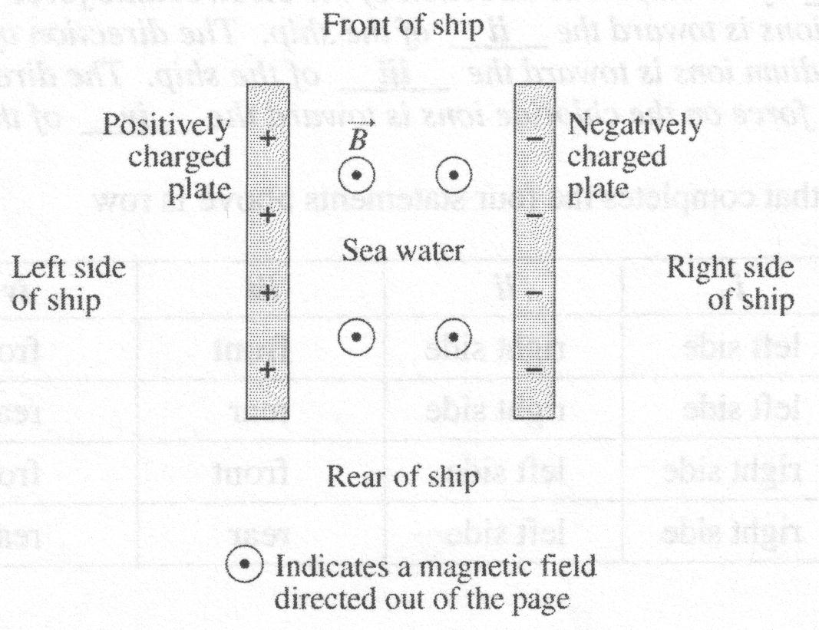

**Specifications for a Prototype MHD Thruster**

Distance between plates 0. 140 m

Electric potential difference between plates 170 V

Magnetic field intensity in region between plates 4.0 T

1. The direction of the uniform electric field created between the charged parallel plates shown in the diagram is toward the

A. left side of the ship

B. right side of the ship

C. front of the ship

D. rear of the ship

Numerical Response

1. The electric field strength between the positively charged and negatively charged parallel plates, expressed in scientific notation, is ***a***.***bc*** × 10***d*** V/m. The values of ***a***, ***b***, ***c***, and ***d*** are ____, ____, ____, and ____ .

(Record all **four digits** of your answer in the numerical‑response section on the answer sheet.)

1. *The direction of the electrostatic force on the positively charged ions is toward the __****i****__ of the ship. The direction of the electrostatic force on the negatively charged ions is toward the __****ii****__ of the ship. The direction of the magnetic force on the sodium ions is toward the __****iii****__ of the ship. The direction of the magnetic force on the chloride ions is toward the __****iv****__ of the ship*.

The row that completes the four statements above is row

|  |  |  |  |  |
| --- | --- | --- | --- | --- |
| **Row** | ***i*** | ***ii*** | ***iii*** | ***iv*** |
| **A.** | left side | right side | front | front |
| **B.** | left side | right side | rear | rear |
| **C.** | right side | left side | front | front |
| **D.** | right side | left side | rear | rear |

______________________________

*Use the following information to answer the next seven questions.*

There are many different types of propulsion engines for satellites. One type of ion propulsion thrust chamber and the satellite to which it is attached are described below. The cylindrical thrust chamber of the engine has a central spike. Electromagnets are used to produce a non-uniform magnetic field directed radially toward the spike. A virtual cathode consisting of trapped electrons is located at the rear of the thrust chamber. An electric field exists between the anode and the virtual cathode. Positive xenon ions enter the thrust chamber at the anode and accelerate toward the virtual cathode, which results in thrust on the satellite. As the xenon ions pass through the virtual cathode, they pick up electrons and neutral xenon atoms fly out of the chamber.



**Thrust Chamber Specifications**

Magnetic field intensity at the location where the xenon ions enter 0.0200 T

Electric field intensity at the location where the xenon ions enter 1.00 × 104 V/m

Mass of one xenon ion, Xe+ 2.19 × 10-25 kg

Exit speed of neutral xenon atom with respect to the thrust chamber 1.5 × 104 m/s

1. In diagram II on the previous page, the direction of the **electric field** in region Y is

A. to the right

B. to the left

C. into the page

D. out of the page

1. As the xenon ions, Xe+, move through region Y, as labeled in diagram II on the previous page, they experience both electric and magnetic forces. The direction of the **magnetic force** that they experience is

A. into the page

B. out of the page

C. toward the top of the page

D. toward the bottom of the page

1. The xenon ions, Xe+, enter the thrust chamber at a negligible speed. The minimum distance between the anode and the virtual cathode that is required to produce the exit speed is

A. 1.2 × 10-16 m

B. 1.0 × 10-6 m

C. 1.5 × 10-2 m

D. 1.4 × 1012 m

Numerical Response

1. While in the thrust chamber, a xenon ion experiences an impulse, expressed in scientific notation, of ***a.b*** × 10-***cd*** kg⋅m/s. The values of ***a***, ***b***, ***c***, and ***d*** are _____, _____, _____, and _____.

(Record all **four digits** of your answer in the numerical-response section on the answer sheet.)

*Use the following additional information to answer the next question.*

Xenon ions, *m*ion, reach the virtual cathode with a speed of *v*1. When a xenon ion collides with a stationary electron, *m*e, in the virtual cathode, the xenon atom, *m*atom, formed has a speed of *v*2.

1. The relationship between *v*2 and *v*1 can be expressed as

A. 

B. 

C. 

D. 

*Use the following additional information to answer the next two questions.*

**Ion Propulsion Engine and Satellite Specifications**

Average thrust applied by the engine to the satellite 0.200 N

Mass of satellite and propulsion system 2.5 × 103 kg

Speed of xenon atom exiting the thrust chamber 1.5 × 104 m/s

Mass of xenon atom 2.19 × 10-25 kg

1. The length of time, in hours, that this type of ion propulsion engine must be in operation in order to increase the speed of the satellite and propulsion system by 12.0 m/s is

A. 0.0240 h

B. 41.7 h

C. 250 h

D. 1.50 × 105 h

1. The number of xenon atoms that would have to be discharged as exhaust in order to increase the speed of the satellite and propulsion system described above by 1.00 m/s is

A. 5.1 × 1019 atoms

B. 7.8 × 1021 atoms

C. 1.6 × 1022 atoms

D. 7.6 × 1023 atoms

_________________________________

*Use the following information to answer the next five questions*.

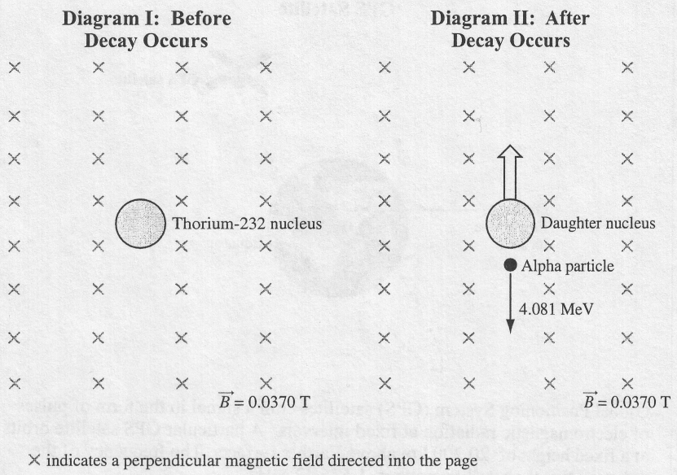

Diagram I represents a thorium-232 nucleus that is stationary in an external magnetic field that has an intensity of 0.0370 T. Diagram II represents what happens at the instant that the thorium nucleus decays. An alpha particle is emitted with an energy of 4.081 MeV, and the daughter nucleus, which has a mass of 3.79 × 10-25 kg, moves in the direction shown.

1. The nuclear decay equation for the decay of thorium-232 described above is

A. 

B. 

C. 

D. 

1. At the instant of disintegration as illustrated in diagram II, the alpha particle, which is travelling in the magnetic field, will be deflected in a manner that would be represented as being

A. into the page

B. out of the page

C. to the left of the page

D. to the right of the page

1. The speed of the emitted alpha particle is

A. 7.01 × 106 m/s

B. 1.40 × 107 m/s

C. 1.98 × 107 m/s

D. 2.80 × 107 m/s

*Use your recorded answer from* ***Multiple Choice 74*** *to answer* ***Numerical Response 11****.* *

Numerical Response

1. The recoil speed of the daughter nucleus, expressed in scientific notation, is ***a*.*bc*** × 10***d*** m/s. The values of ***a***, ***b***, ***c***, and ***d*** are ___, ____, ___, and ___.

(Record all **four digits** in the numerical-response section on the answer sheet.)

**\*You can receive marks for this question even if the previous question was answered incorrectly.**

*Use your recorded answer from* ***Multiple Choice 74*** *to answer* ***Numerical Response 12****.* *

Numerical Response

1. The radius of curvature of the path followed by the alpha particle in the magnetic field is ______ m.

(Record your **three-digit answer** in the numerical-response section on the answer sheet.)

**\*You can receive marks for this question even if the previous question was answered incorrectly.**

*Use the following graph to answer the next question*.

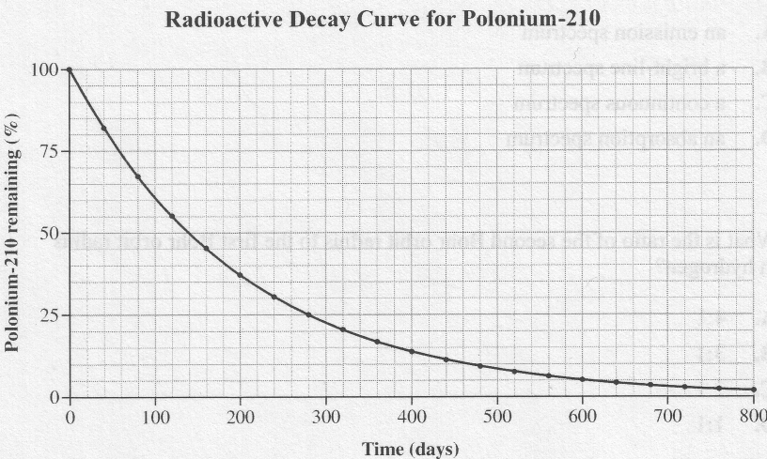

Numerical Response

1. According to the graph above, the half-life of polonium-210 is _____ days.

(Record your **three-digit answer** in the numerical-response section on the answer sheet.)

___________________________

*Use the following information to answer the next question*.

In a piece of new wood, the rate of radioactive decay of carbon-14 is 816 decays per hour per gram. The half-life of carbon-14 is approximately 5 730 years.

The decay rate of carbon-14 in a particular wooden archaeological artefact is 12.75 decays per hour per gram.

1. The age of the wooden artefact is

A. 3.68 × 105 years

B. 3.44 × 104 years

C. 89.2 years

D. 64.3 years

*Use the following information to answer the next five questions*.

**Transuranic Elements**

Transuranic elements have more protons than uranium. Because all transuranic elements have a relatively short half-life, they are almost absent from our solar system. Physicists have made transuranic elements by bombarding heavy ions with magnesium ions and oxygen ions.

In a particular bombardment, a physicist uses magnesium ions (28Mg2+) with a mass of 4.67 × 10-26 kg and accelerates them to a kinetic energy of 1.64 × 10-13 J.

1. In this bombardment, the speed of a magnesium ion is

A. 1.87 × 106 m/s

B. 2.65 × 106 m/s

C. 3.51 × 1012 m/s

D. 7.02 × 1012 m/s

1. The electric potential difference that accelerates the magnesium ion is

A. 9.76 × 10-7 V

B. 1.95 × 10-6 V

C. 5.13 × 105 V

D. 1.03 × 106 V

1. Magnesium-28 undergoes a beta decay according to the nuclear reaction equation

A. 

B. 

C. 

D. 

1. A physicist starts a 7.0 day experiment with 0.20 g of magnesium-28. If the half-life of magnesium-28 is 21 h, then the mass of magnesium-28 remaining at the end of the experiment will be

A. 1.8 × 10-1 g

B. 3.9 × 10-3 g

C. 7.8 × 10-4 g

D. 9.5 × 10-8 g

1. In order to produce dubnium-262 (), berklium-249 () is bombarded with very fast-moving oxygen nuclei. This reaction also produces five neutrons. The nuclear reaction for the production of dubnium-262 is

A. 

B. 

C. 

D. 

_______________________________________

*Use the following information to answer the next six questions.*

**One Solar Nuclear Fusion Reaction Equation**





One way to harness this energy on Earth is to use a nuclear fusion reactor. One of the problems in terrestrial fusion reactors is the very high energy required to overcome the electrostatic repulsive force between the deuterium ions and the tritium ions.

A particular reactor design uses magnetic fields in a process called magnetic confinement to keep the ions inside the reactor. However, neutrons escape magnetic confinement. These neutrons are captured by a shield called a lithium blanket.

1. Energy is released in this nuclear fusion reaction because the

A. free neutron has a high energy

B. number of protons remains the same

C. number of nucleons remains the same

D. mass of the alpha particle and neutron is less than the mass of the intermediate product

**Numerical Response**

Numerical Response

1. At a particular instant, the electrostatic force that the deuterium ion exerts on the tritium ion is 23.3 N. The distance between the centres of the two ions, expressed in scientific notation, is __________ × 10–*w* m.

(Record your **three-digit answer** in the numerical-response section on the answer sheet.)

*Use the following additional information to answer the next question.*

A positively charged deuterium ion enters a magnetic field directed out of the page, as shown below.



1. The direction of the magnetic deflecting force that acts on the positively charged deuterium ion as it just enters the magnetic field is

A. into the page

B. out of the page

C. toward the top of the page

D. toward the bottom of the page

1. The neutron produced in the fusion reaction escapes the magnetic confinement because

A. neutral particles are not deflected by magnetic fields

B. the neutron is moving so fast that it escapes the magnetic field

C. the energy produced in the nuclear reaction is enough to cause the neutron to escape

D. conservation of momentum requires that the neutron has to be pushed in the opposite direction to that of the helium produced

1. *As a particular neutron travelling at 5.21 × 106 m/s hits the lithium blanket and stops, it experiences an impulse of __****i__*** *, and the neutron–lithium collision is classified as __****ii__*** *.*

The statements above are completed by the information in row

|  |  |  |
| --- | --- | --- |
| **Row** | ***i*** | ***ii*** |
| A. | –8.70 × 10–21 N⋅s | elastic |
| B. | –8.70 × 10–21 N⋅s | inelastic |
| C. | –2.27 × 10–14 J | elastic |
| D. | –2.27 × 10–14 J | inelastic |

1. Which of the following equations most likely describes a neutron–lithium collision?

A. 

B. 

C. 

D. 

_______________________________

1. To study sub-nuclear structure, high-energy particle accelerators are required because

A. plasma exists at high energy

B. antimatter exists at high energy

C. of the short-range effect of the electrostatic force

D. of the short-range effect of the strong nuclear force

1. Which of the following decay equations describes beta positive decay?

A. 

B. 

C. 

D. 

*Use the following information to answer the next question*.

The first evidence of antimatter was a photograph of the track produced by a positron as it moved through a perpendicular magnetic field inside a cloud chamber.

An electron moving in one direction through a magnetic field in a cloud chamber leaves a track identical to that of a positron moving in the opposite direction. To prove that a track was made by a positron, scientists conducted an experiment: a thin lead barrier was placed across the path of the particle to slow the particle as it passed through the barrier, thereby revealing the particle's direction of travel. The results of this experiment are illustrated below.

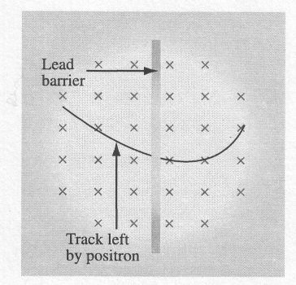

× Represents a magnetic field directed into the page

1. The relative speed of the positron on either side of the barrier is determined by comparing the

A. length of the track on either side of the barrier

B. direction of the curvature on either side of the barrier

C. strength of the magnetic field on either side of the barrier

D. radius of the curvature of the path on either side of the barrier

______________________________

*Use the following information to answer the next question*.

Each of the following statements gives a characteristic of either a fusion reaction or a fission reaction.

**1** A heavy nucleus is split into two or more lighter nuclei.

**2** Two nuclei are combined into one.

**3** It is the dominant nuclear reaction in the sun.

**4** The products of the reaction are harmless.

**5** The reaction produces radioactive isotopes.

**6** Extremely high temperatures are needed to start the reaction.

Numerical Response

1. The statements above that describe nuclear **fusion**, listed in ascending order, are ____, ____, ____, and ____.

(Record all **four digits of your** answer in the numerical-response section on the answer sheet.)

______________________________

1. *The* *product of radioactive decay that penetrates matter the least is the ___****i****___ particle, because of its relatively ___****ii****___ mass and charge*.

The statement above is completed by the information in row

|  |  |  |
| --- | --- | --- |
| **Row** | ***i*** | ***ii*** |
| A. | alpha | small |
| B. | alpha | large |
| C. | beta negative | small |
| D. | beta negative | large |

**Answers**

**Multiple choice Numerical Response**

|  |  |  |  |  |
| --- | --- | --- | --- | --- |
| 1. C 2. B 3. A 4. D 5. C 6. B 7. B 8. B 9. A 10. C 11. B 12. C 13. B 14. D 15. B 16. D 17. B 18. C 19. A 20. C 21. B 22. D 23. D | 1. B 2. B 3. D 4. D 5. D 6. B 7. A 8. C 9. C 10. A 11. B 12. B 13. A 14. C 15. D 16. A 17. A 18. C 19. A 20. A 21. D 22. D 23. A | 1. B 2. D 3. D 4. D 5. A 6. D 7. C 8. C 9. C 10. B 11. A 12. D 13. B 14. B 15. B 16. B 17. B 18. B 19. D 20. A 21. B 22. C 23. C | 1. B 2. D 3. C 4. D 5. B 6. B 7. B 8. C 9. B 10. C 11. D 12. D 13. D 14. A 15. B 16. A 17. D 18. D 19. D 20. B | 1. 4.12 2. 1503 3. 4431 4. 36 5. 3857 6. 2113 7. 7.50 8. 1.62 9. 1213 10. 3321 11. 2465 12. 7.86 13. 140 14. 3.14 15. 2346 |